**Tutorial 3: Methods & Click Events**

Make sure **Tutorial 2** is complete to be able to move on to this tutorial or clone the [vue3-firebase-course](https://github.com/younggrasshopperza/vue3-firebase-course) repository and go to branch called **Tutorial-2**.

In the **app.js** file, make sure the values in the **data** function that is being returned has the below values:

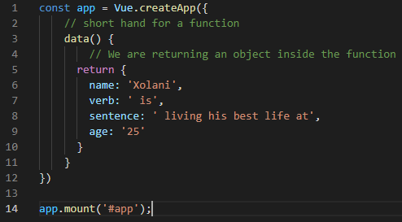

**Step 1:** Continuing from Tutorial 2, in the **index.html** file, create a **button tag** using a **Vue directive** “**v-on**” or “**@**” and attach a **click event**. **Increment** the **age** by **1**. Make sure you have an age data property with a numeric value.

Look at example below (**Line 19**):

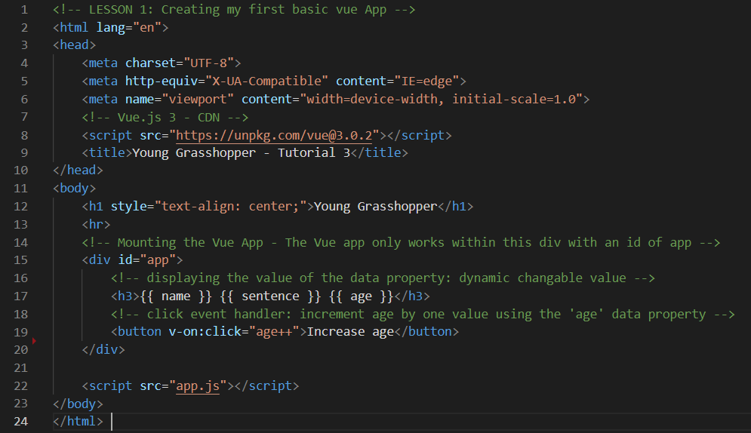

Click the **button**, “**Increase age**” on the browser and watch the value **increment**.

**Output:**

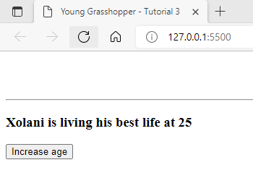

**Step 2:** In the **index.html** file, create a **button tag** to **decrease** the **age** by **1**.

Look at example below (**Line 23**):

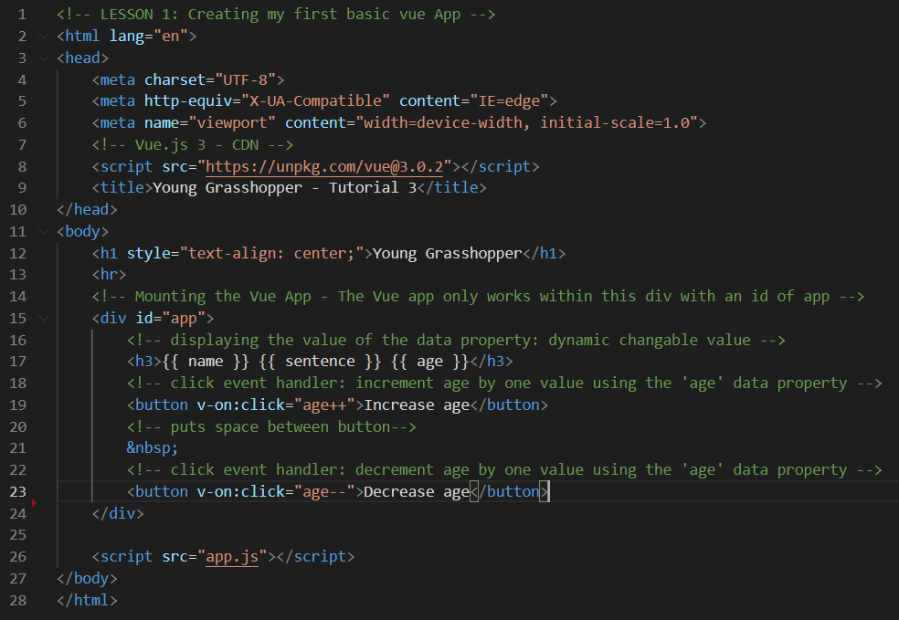

Click the **button**, “**Decrease age**” on the browser and watch the value **decrease**.

**Output:**

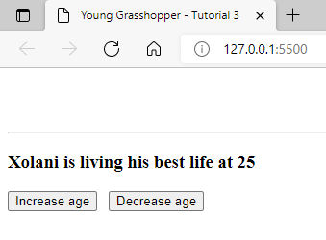

**Step 3:** In the **index.html** file, create a **div tag** that is **clickable** using an “**@**” symbol that will change the default name to Sarah.

Look at example below (**Line 26**):

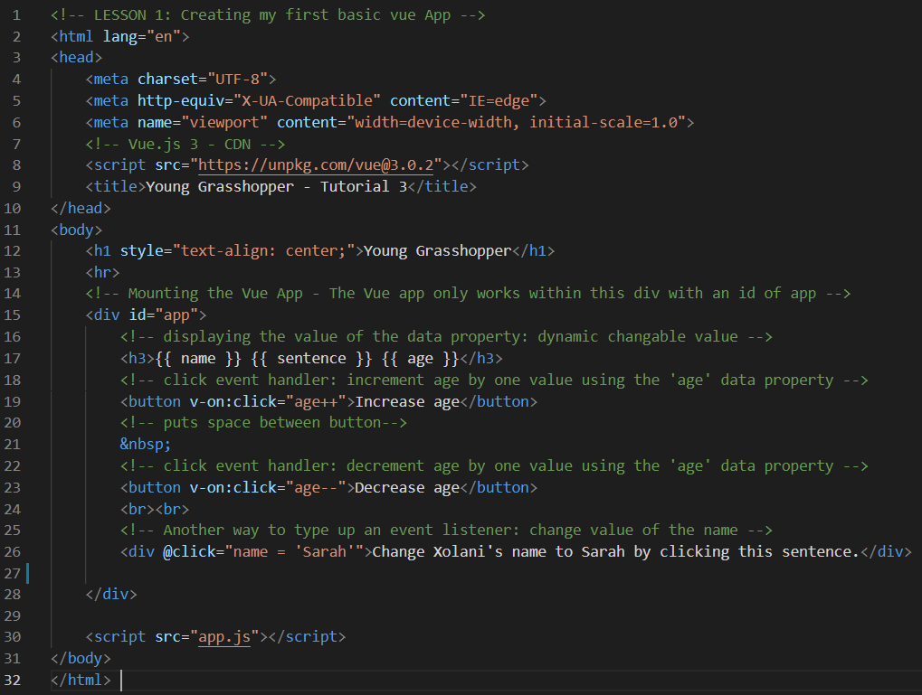

Click the **div**, output value on the browser and watch the **name** value change.

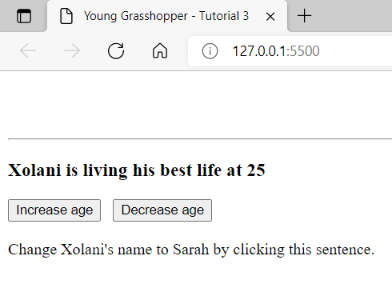

**Output**: Xolani changed to Sarah

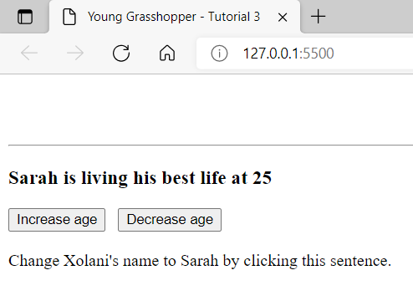

**Step 4:** In app.js file, create a **component method**. Add a **methods** property where the Vue App is being initialised either above or below the data property. Create a method called “**changeName**”. Attach the method in the **index.html** file to a clickable **div**.

Look at **app.js** in the example below (**Line 11 to 16**).

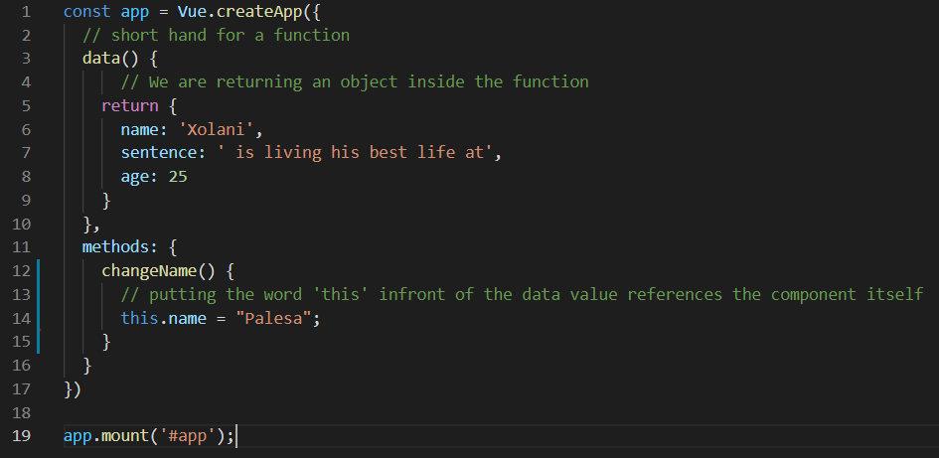

Look at **index.html** in the example below (**Line 29**).

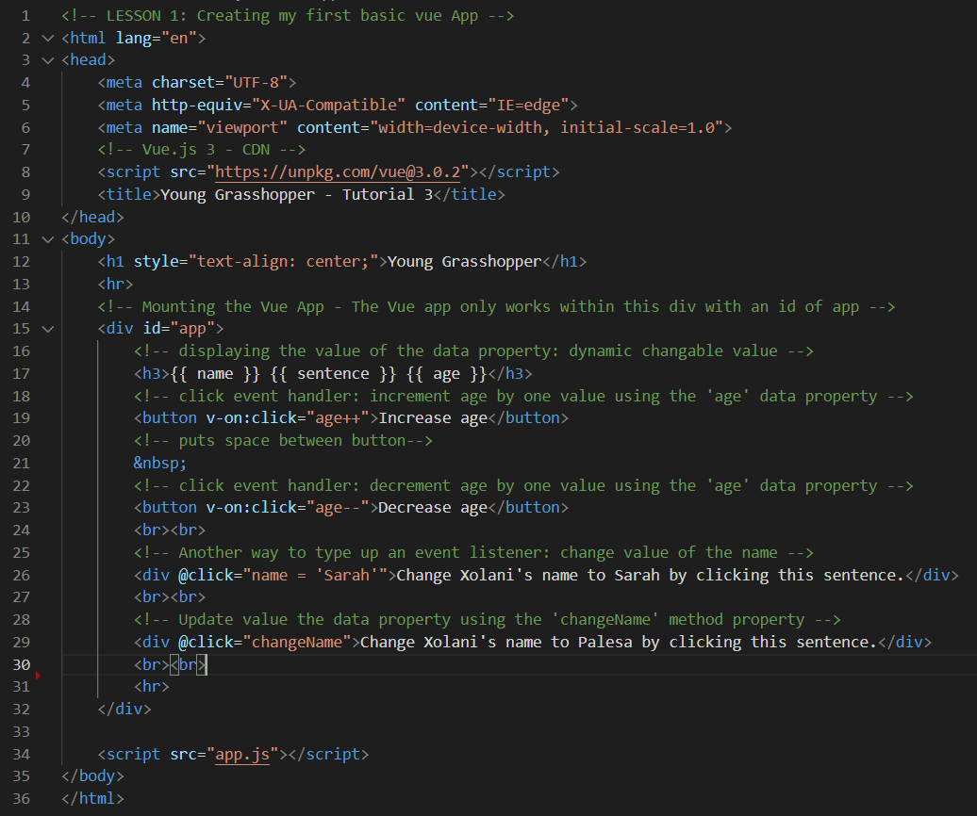

Click the **div**, output value on the browser and watch the **name** value change.

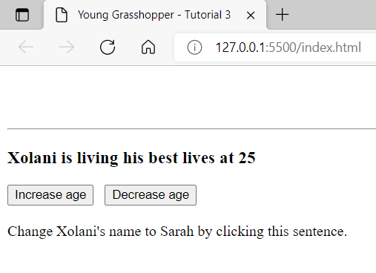

**Output**: Xolani changed to Sarah

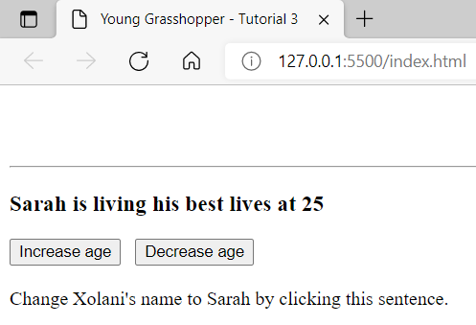

**Step 5:** Create a method called “**changeSentence**” that passes an argument. Attach the method in the **index.html** file to a clickable **div** with a default argument passed in the parameter.

Look at **app.js** in the example below (**Line 17 to 19**).

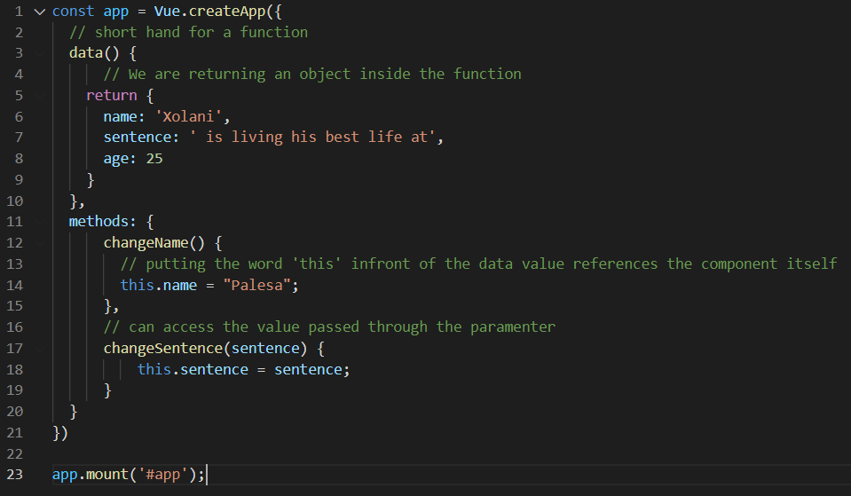

Look at **index.html** in the example below (**Line 32**).

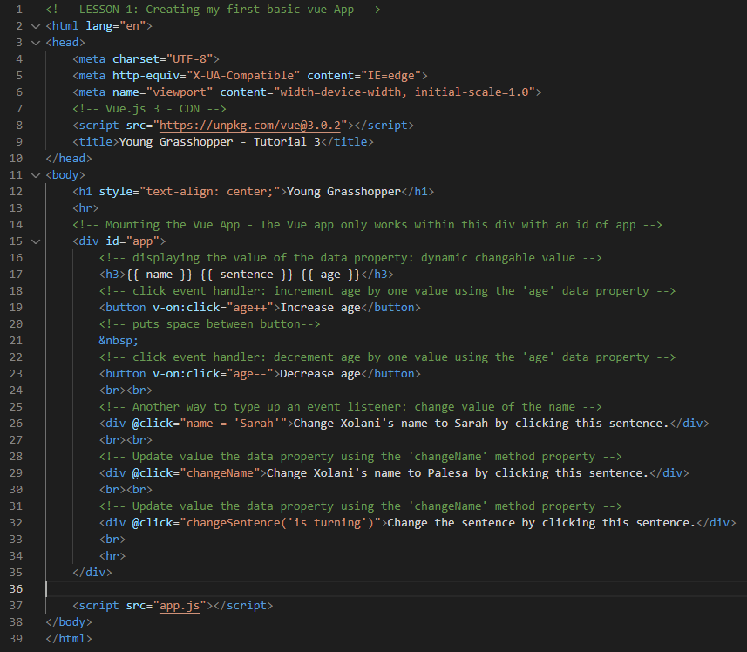

**You can view the code snippets from the** [**vue3-firebase-course**](https://github.com/younggrasshopperza/vue3-firebase-course) **repository under the Tutorial-3 branch.**